EXPERIMENT NUMBER: 1
Aim: To Understand the concept of various tools use for digital marketing in a business scenario.
Procedure: Digital Marketing
Any marketing that uses electronic devices and can be used to convey promotional messaging. Digital marketing typically refers to marketing campaigns that appear on a computer, phone,tablet,or other device. It can take many forms, including online videos, display ads, search engine marketing, paid social ads and social media posts. Digital marketing, also called online marketing, is the promotion of brands to connect with potential customers using internet and other forms of digital communication. This includes not only email, social media, and web-based advertising, but also text and multimedia messages as a marketing channel.
The way digital marketing works is very simple. First you need to specify your digital marketing goals i.e. what you want to achieve in digital marketing. Then you need to decide which marketing channel can help you acheive your goals. For example, if your goal is to make more sales then running paid campaigns on google is good. To make whole process easier to manage, you can create a plan specifying how much money you will spend, define target audience, define your performance metrics and other information that will help you control the process.
This is what a digital marketing campaign is all about. Before creating your first digital marketing campaign, you need to know the different marketing channels and how they work.
There are various types of tools:
- Search Engine Optimization (SEO)
- Google Analytics
- Google Ads
- Pay-per-Click
- Email Marketing
- Affiliate Marketing
- Social Media Marketing
- Link Building
- Content Marketing
- Mobile Marketing
The information about the tools of Digital Marketing mentioned above is given below one by one.
1. Search Engine Optimization (SEO)
Search engine optimization (SEO) is the process of improving the quality and quantity of website traffic to a website or a web page from search engines. SEO targets unpaid traffic (known as "natural" or "organic" results) rather than direct traffic or paid traffic. Unpaid traffic may originate from different kinds of searches, including image search, video search, academic search, news search, and industry-specific vertical search engines.
As an Internet marketing strategy, SEO considers how search engines work, the computer-programmed algorithms that dictate search engine behavior, what people search for, the actual search terms or keywords typed into search engines, and which search engines are preferred by their targeted audience. SEO is performed because a website will receive more visitors from a search engine when websites rank higher on the search engine results page (SERP). These visitors can then potentially be converted into customers.
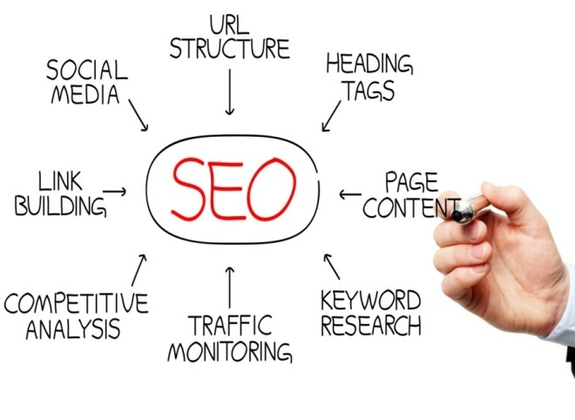
2. Google Analytics
Google Analytics is a web analytics service offered by Google that tracks and reports website traffic, currently as a platform inside the Google Marketing Platform brand.[ Google Analytics is used to track website activity such as session duration, pages per session and the bounce rate of individuals using the site, along with the information on the source of the traffic. It can be integrated with Google Ads, with which users can create and review online campaigns by tracking landing page quality and conversions (goals).
Goals might include sales, lead generation, viewing a specific page, or downloading a particular file. Google Analytics' approach is to show high-level, dashboard-type data for the casual user, and more in-depth data further into the report set. Google Analytics analysis can identify poorly performing pages with techniques such as funnel visualization, where visitors came from (referrers), how long they stayed on the website and their geographical position. It also provides more advanced features, including custom visitor segmentation. Google Analytics e-commerce reporting can track sales activity and performance. The e-commerce reports show a site's transactions, revenue, and many other commerce-related metrics.
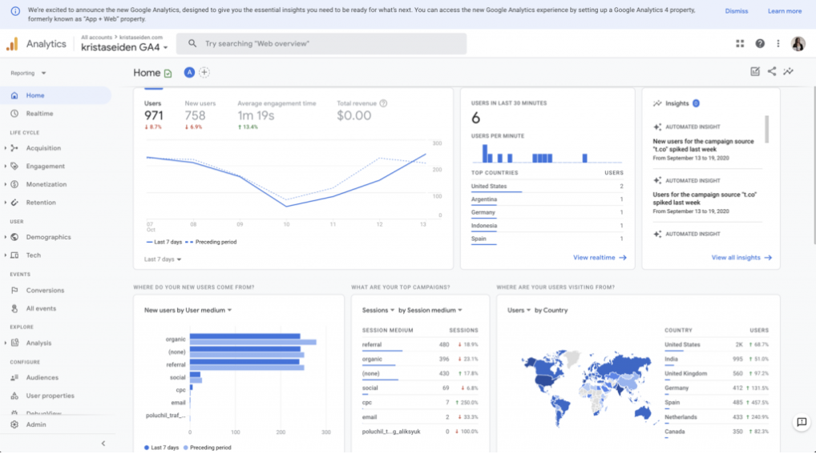
3. Google Ads
Google Ads- Google ads is an online advertising platform developed by Google, where advertisers bid to display brief advertisements, service offerings, product listings, or videos to web users. It can place ads both in the results of search engines like Google Search (the Google Search Network) and on non-search websites, mobile apps, and videos.
Services are offered under a pay-per-click (PPC) pricing model. Google Ads' system is based partly on cookies and partly on keywords determined by advertisers. Google uses these characteristics to place advertising copy on pages that they think might be relevant. Advertisers pay when users divert their browsing to click on the advertising copy. Adverts can be implemented locally, nationally, or internationally.
Google's text advertisements mimic what the average search result looks like on Google. Image ads can be one of the several different standardized sizes as designated by the Interactive Advertising Bureau (IAB). In May 2016, Google announced Expanded Text Ads, allowing 23% more text. Besides the Google search engine, advertisers also have the option of enabling their ads to show on Google's partner networks, a list of sites including AOL search, Ask.com, and Netscape, who receive a portion of generated income.
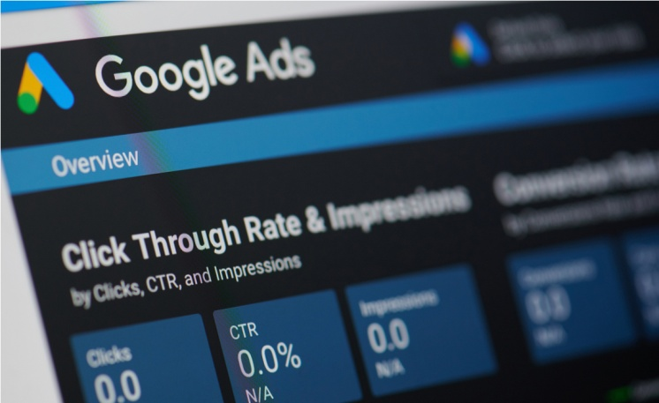
4. Pay-per-Click
Pay-per-click (PPC) is an internet advertising model used to drive traffic to websites, in which an advertiser pays a publisher (typically a search engine, website owner, or a network of websites) when the ad is clicked.
Pay-per-click is usually associated with first-tier search engines (such as Google Ads, Amazon Advertising, and Microsoft Advertising formerly Bing Ads). With search engines, advertisers typically bid on keyword phrases relevant to their target market and pay when ads (text-based search ads or shopping ads that are a combination of images and text) are clicked. In contrast, content sites commonly charge a fixed price per click rather than use a bidding system.
PPC display advertisements, also known as banner ads, are shown on web sites with related content that have agreed to show ads and are typically not pay-per-click advertising, but instead usually charge on a cost per thousand impressions (CPM).
Social networks such as Facebook, Instagram, LinkedIn, Reddit, Pinterest, Tik Tok, and Twitter have also adopted pay-per-click as one of their advertising models. The amount advertisers pay depends on the publisher and is usually driven by two major factors: quality of the ad, and the maximum bid the advertiser is willing to pay per click measured against its competitors' bids. In general, the higher the quality of the ad, the lower the cost per click is charged and vice versa.
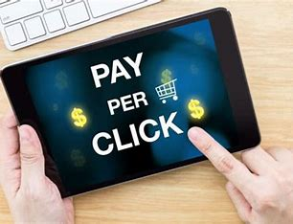
5. Email Marketing
Email marketing is a powerful marketing channel, a form of direct marketing as well as digital marketing, that uses email to promote your business’s products or services. It can help make your customers aware of your latest items or offers by integrating it into your marketing automation efforts. It can also play a pivotal role in your marketing strategy with lead generation, brand awareness, building relationships or keeping customers engaged between purchases through different types of marketing emails.
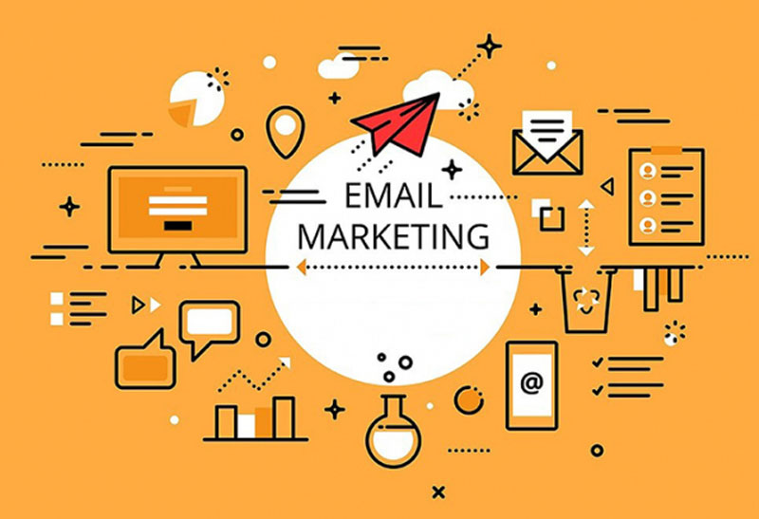
6. Affiliate Marketing
Affiliate marketing is an advertising model in which a company compensates third-party publishers to generate traffic or leads to the company’s products and services. The third-party publishers are affiliates, and the commission fee incentivizes them to find ways to promote the company.
Affiliate marketing is a marketing scheme in which a company compensates partners for business created from the affiliate's marketing tactics.
Digital marketing, analytics, and cookies have made affiliate marketing a billion-dollar industry.
Firms typically pay affiliates per sale and less frequently by clicks or impressions.
The three main types of affiliate marketing are unattached affiliate marketing, involved affiliate marketing, and related affiliate marketing.
7. Social Media Marketing
Social media marketing is a powerful way for businesses of all sizes to reach prospects and customers. People discover, learn about, follow, and shop from brands on social media, so if you’re not on platforms like Facebook, Instagram, and LinkedIn, you’re missing out! Great marketing on social media can bring remarkable success to your business, creating devoted brand advocates and even driving leads and sales.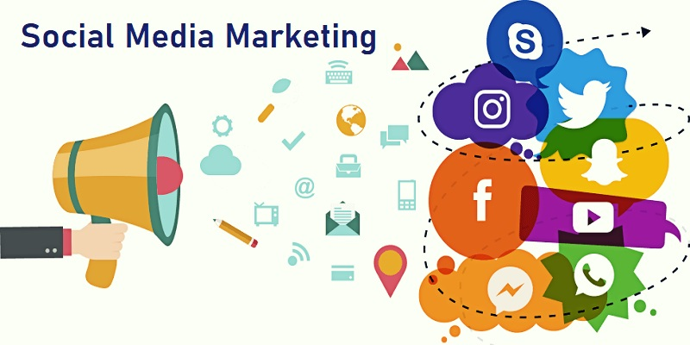
8. Link Building
Link building is the process of acquiring hyperlinks from other websites to your own. A hyperlink (usually just called a link) is a way for users to navigate between pages on the Internet. Search engines use links to crawl the web. They will crawl the links between the individual pages on your website, and they will crawl the links between entire websites.
Not all links are deliberately built by SEOs or marketers. Many of them will be created for a range of reasons such as a journalist covering a news story and linking to a source, or a blogger who loves their new coffee machine so much that they link to the retailer who sold it to them.
Acquiring links that you didn’t ask for is the nirvana of SEO. It's always something that you should be striving for and building towards over the long term. You do this by putting in the work to make your website link-worthy, whether that’s through a great product or aspect of your service, or via producing great content that is referenced by other websites.
Alongside this long-term approach, you can also leverage a range of link building techniques which allow you to build your authority and increase your chances of ranking well and getting traffic from organic search.
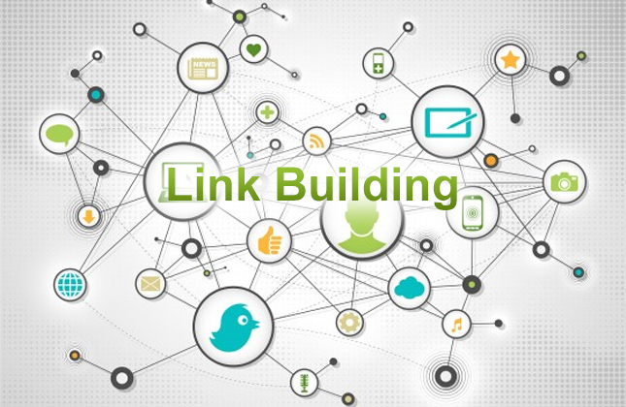
9. Content Marketing
Content marketing is a marketing strategy used to attract, engage, and retain an audience by creating and sharing relevant articles, videos, podcasts, and other media. This approach establishes expertise, promotes brand awareness, and keeps your business top of mind when it’s time to buy what you sell.
A content marketing strategy establishes your brand as a thought leader, boosting trust among your audience by creating and distributing content in various ways. Content marketing is a type of inbound marketing that attracts customers and builds loyalty, making it effective for customer retention.
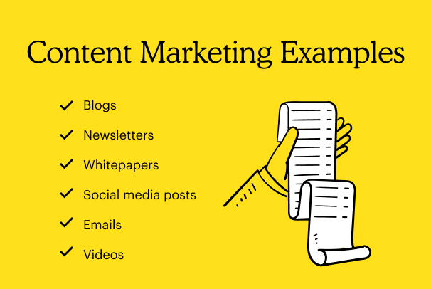
10. Mobile Marketing
Mobile marketing is any advertising activity that promotes products and services via mobile devices, such as tablets and smartphones. It makes use of features of modern mobile technology, including location services, to tailor marketing campaigns based on an individual's location.

Mobile marketing is a way in which technology can be used to create personalized promotion of goods or services to a user who is constantly connected to a network.
Mobile marketing is an indispensable tool for companies large and small as mobile devices have become ubiquitous. The key players in the space are the brands (and companies that they represent through advertising), and service providers that enable mobile advertising. 